**#Python program to show the concept of functions.**

def checkEven():

num1=int(input("Enter a number:"))

if num1%2==0:

print(num1,'is even')

return None

def checkOdd():

num1=int(input("Enter a number:"))

if num1%2==1:

print(num1, 'is odd')

return None

checkEven()

checkOdd()

**OUTPUT**

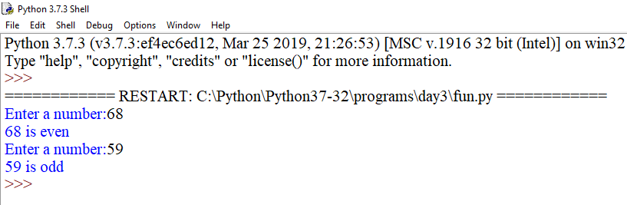

**#Python program to show the concept of function with arguments.**

def checkEven(num1):

if num1%2==0:

print(num1,'is even')

return None

def checkOdd(num1):

if num1%2==1:

print(num1, 'is odd')

return None

num=int(input('Enter a number'))

checkEven(num)

checkOdd(num)

**OUTPUT**

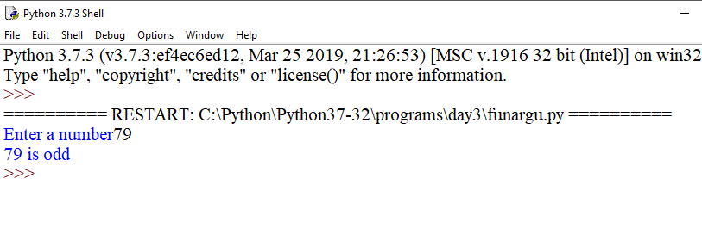

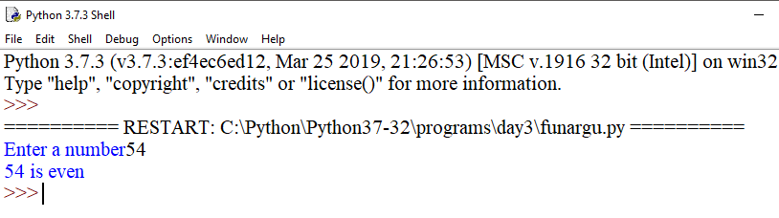

**#Python program to show if else condition in functions.**

def checkEvenOdd():

num1=int(input("Enter a number:"))

if num1%2==0:

print(num1,'is even')

print('if block code executed')

else:

print(num1, 'is odd')

print('else block code executed')

return None

checkEvenOdd()

**OUTPUT**

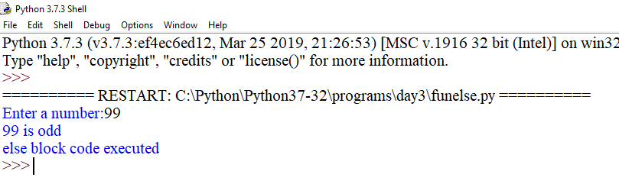

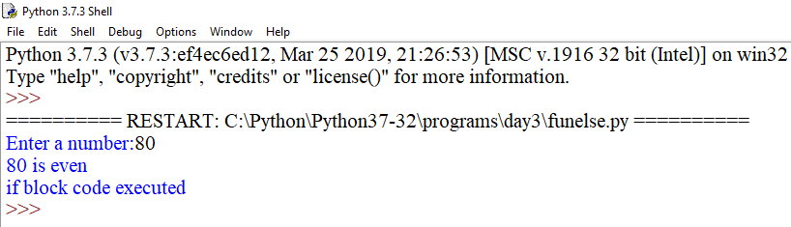

**# Python program to show if else condition in function with arguments.**

def checkEvenOdd(num1):

if num1%2==0:

print(num1,'is even')

print('if block code executed')

else:

print(num1, 'is odd')

print('else block code executed')

return None

num1=int(input("Enter a number"))

checkEvenOdd(num1)

**OUTPUT**

